**FITFLEX: YOUR PERSONAL FITNESS COMPANION**

**(FITNESS TRACKER)**

**Team Leader : Keerthana S**

**Team Members : Keerthana L, Keerthana J, Keerthana M**

**ABSTRACT :**

FitFlex is a modern fitness tracking application designed to help users track their workouts, monitor progress, and achieve their fitness goals efficiently. Built using React.js for the front end and Node.js for the back end, the application provides a user-friendly and interactive platform for fitness enthusiasts. Key features include workout logging, goal setting, nutrition tracking, progress monitoring, and personalized reminders. By leveraging a responsive UI and a scalable backend, FitFlex aims to create a seamless experience that keeps users engaged and motivated throughout their fitness journey.

**INTRODUCTION:**

In today’s fast-paced world, maintaining a healthy lifestyle can be challenging. Many individuals struggle with tracking their workouts, maintaining consistency, and measuring progress effectively. FitFlex is designed to address these challenges by offering a personalized fitness tracking solution.

FitFlex allows users to log their workouts, set fitness goals, track nutrition, and monitor their progress with ease. The application utilizes React.js for a dynamic and engaging front-end experience, while Node.js ensures a robust and scalable backend. With features such as real-time progress charts, workout reminders, and customized goal setting, FitFlex serves as an all-in-one fitness companion, helping users stay motivated and achieve their fitness aspirations.

**DESCRIPTION:**

FitFlex is an innovative fitness app designed for all fitness levels, offering a seamless and interactive experience. With an intuitive interface, it provides diverse workouts like strength training, cardio, yoga, and HIIT. Users can explore exercises with dynamic search, track progress through AI-powered insights, and receive personalized workout plans.

FitFlex fosters a supportive community where users share experiences and stay motivated together. Featuring smart tracking, real-time recommendations, and interactive charts, it ensures an engaging and effective fitness journey. Whether at home, in the gym, or on the go, FitFlex is the ultimate wellness companion, making fitness accessible, enjoyable, and goal-driven.

**SCENARIO BASED INTRODUCTION:**

Lace up and take the first step in your fitness journey with FitFlex—the app that redefines workouts. With a sleek interface, personalized plans, expert guidance, and a supportive community, FitFlex makes fitness exciting and accessible. Whether it’s HIIT, strength training, or flexibility, every move is tracked, every milestone celebrated.

This isn’t just another fitness app—it’s your path to a smarter, more engaging workout experience. Welcome to FitFlex. Your journey starts now.

**PROJECT OBJECTIVES:**

Intuitive UI/UX: React.js for seamless navigation and engaging design. Diverse Workouts: Structured programs for all fitness levels and preferences.AI-Driven Personalization: Smart workout recommendations based on user goals.

**PROJECT GOALS:**

Enhance Fitness Accessibility – Provide an intuitive and user-friendly platform that allows individuals of all fitness levels to explore and engage with effective workout routines.

Personalized Fitness Experience – Deliver tailored workout plans and progress tracking based on user preferences, goals, and fitness levels.

Foster a Supportive Fitness Community – Create a social space where users can connect, share experiences, and stay motivated through collaboration and encouragement.

**FEATURES OF FITFLEX:**

Personalized Workout Plans: AI-driven, goal-based fitness plans (weight loss, muscle gain, endurance, flexibility). Exercise Library: Diverse workouts (strength, cardio, HIIT, yoga) with step-by-step guides and video demos. Intuitive and User-Friendly Design: Navigate the app seamlessly with a clean, modern interface designed for optimal user experience and clear exercise selection.

**TECHNICAL ARCHITECTURE:**

**PRE-REQUISITES:**

Here are the key prerequisites for developing a frontend application using React.js:

**Node.js and npm:**

Node.js is a powerful JavaScript runtime environment that allows you to run JavaScript code on the local environment. It provides a scalable and efficient platform for building network applications. Install Node.js and npm on your development machine, as they are required to run JavaScript on the server-side.

● Download: <https://nodejs.org/en/download/>

● Installation instructions: <https://nodejs.org/en/download/package-manager/>

**React.js:**

React.js is a popular JavaScript library for building user interfaces. It enables developers to create interactive and reusable UI components, making it easier to build dynamic and responsive web applications.

Install React.js, a JavaScript library for building user interfaces.

● Create a new React app:

npx create-react-app my-react-app

Replace my-react-app with your preferred project name.

● Navigate to the project directory:

cd my-react-app

● Running the React App:

With the React app created, you can now start the development server and see your React application in action.

● Start the development server:

npm start

This command launches the development server, and you can access your React app at [**http://localhost:3000**](http://localhost:3000) in your web browser.

**HTML, CSS, and JavaScript:** Basic knowledge of HTML for creating the structure of your app, CSS for styling, and JavaScript for client-side interactivity is essential.

**Version Control:** Use Git for version control, enabling collaboration and tracking changes throughout the development process. Platforms like GitHub or Bitbucket can host your repository.

●Git: Download and installation instructions can be found at:

<https://git-scm.com/downloads>

**Development Environment:** Choose a code editor or Integrated Development Environment (IDE) that suits your preferences, such as Visual Studio Code, Sublime Text, or WebStorm.

**• Visual Studio Code: Download from** [**https://code.visualstudio.com/download**](https://code.visualstudio.com/download)

**• Sublime Text: Download from** [**https://www.sublimetext.com/download**](https://www.sublimetext.com/download)

**• WebStorm: Download from** [**https://www.jetbrains.com/webstorm/download**](https://www.jetbrains.com/webstorm/download)

To get the Application project from drive:

Follow below steps:

**GET THE CODE:**

<https://drive.google.com/file/d/1QKexhOwJK7ZuTAKes8c4FLZ5EejYWiyT/view?usp=drive_link>

**Install Dependencies:**

**•** Navigate into the cloned repository directory and install libraries:

cd fitness-app-react

npm install

**Start the Development Server:**

**•** To start the development server, execute the following command:

npm start

**Access the App:**

**•** Open your web browser and navigate to[**http://localhost:3000**](http://localhost:3000)

**•** You should see the application's homepage, indicating that the installation and setup were successful.

You have successfully installed and set up the application on your local machine. You can now proceed with further customization, development, and testing as needed.

**PROJECT STRUCTURE**:

In this project, we’ve split the files into 3 major folders, Components, Pages and Styles. In the pages folder, we store the files that acts as pages at different URLs in the application. The components folder stores all the files, that returns the small components in the application. All the styling css files will be stored in the styles folder.

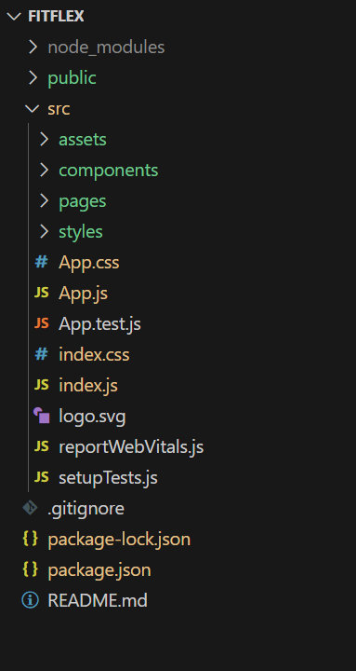 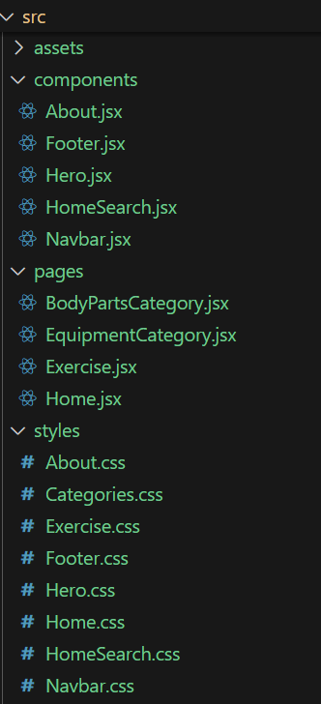

**PROJECT FLOW:**

Project demo:

Before starting to work on this project, let’s see the demo.

Demo link:

<https://drive.google.com/file/d/1Qr4jvnPUUk2gzvSI2ljNxoPlt9p7WXX6/view?usp=drive_link>

Use the code in:

<https://drive.google.com/file/d/1QKexhOwJK7ZuTAKes8c4FLZ5EejYWiyT/view?usp=drive_link>

**Milestone 1: Project setup and configuration.**

**● Installation of required tools:**

To build the FitFlex app, we'll need a developer's toolkit. We'll leverage React.js for the interactive interface, React Router Dom for seamless navigation, and Axios to fetch fitness data. To style the app, we'll choose either Bootstrap or Tailwind CSS for pre-built components and a sleek look.

Open the project folder to install necessary tools. In this project, we use:

* React Js
* React Router Dom
* React Icons
* Bootstrap/tailwind css
* Axios

● For further reference, use the following resources

* <https://react.dev/learn/installation>
* [https://react-bootstrap-v4.netlify.app/getting started/introduction/](https://react-bootstrap-v4.netlify.app/getting%20started/introduction/)
* <https://axios-http.com/docs/intro>
* <https://reactrouter.com/en/main/start/tutorial>

**Milestone 2: Project Development**

❖ Setup the Routing paths

Setup the clear routing paths to access various files in the application.

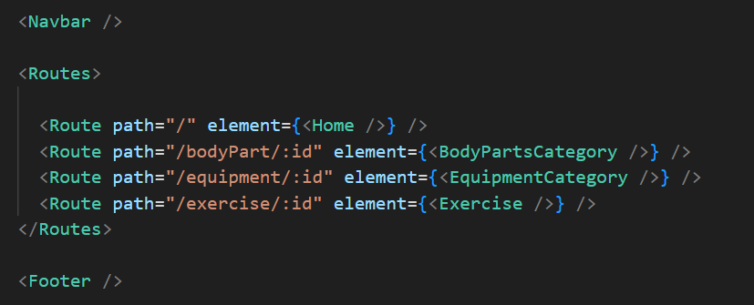

**Important Code snips:**

Fetching available Equipment list & Body parts list

From the Rapid API hub, we fetch available equipment and list of body parts with an API request.

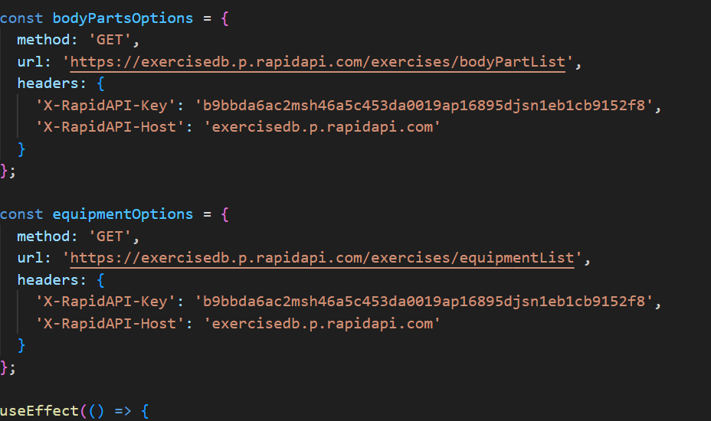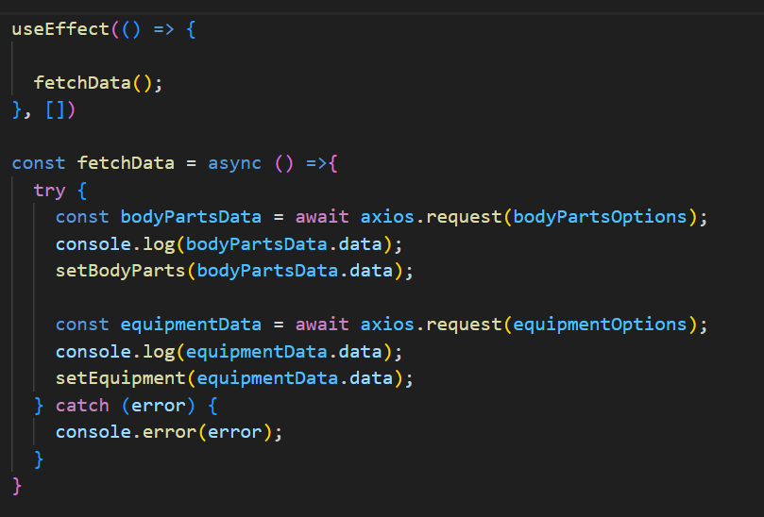

**Fetching exercises under particular category**

To fetch the exercises under a particular category, we use the below code.

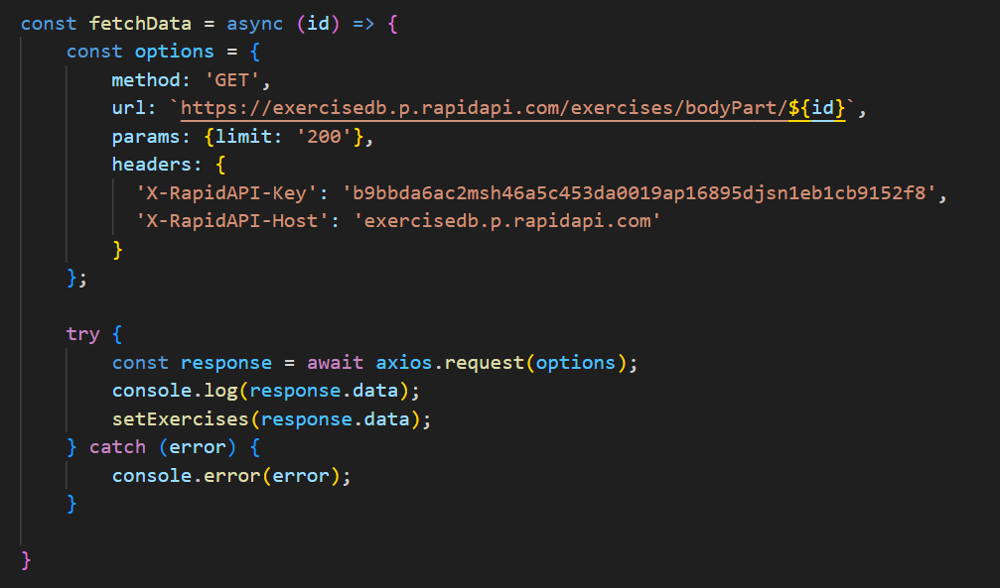

**Project Execution:**

After completing the code, run the react application by using the command “npm start” or “npm run dev” if you are using vite.js Here are some of the screenshots of the application.

**HOME:**

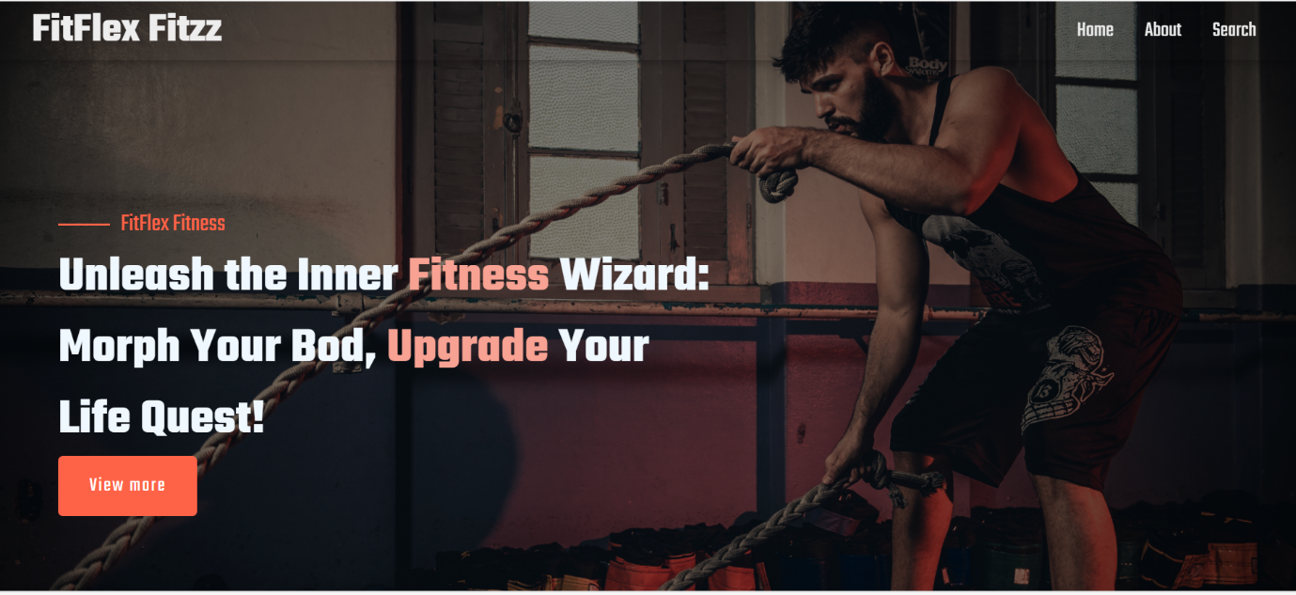

**ABOUT:**

FitFlex Fitzz isn't just another fitness app. We're meticulously designed to transform your workout experience, no matter your fitness background or goals.

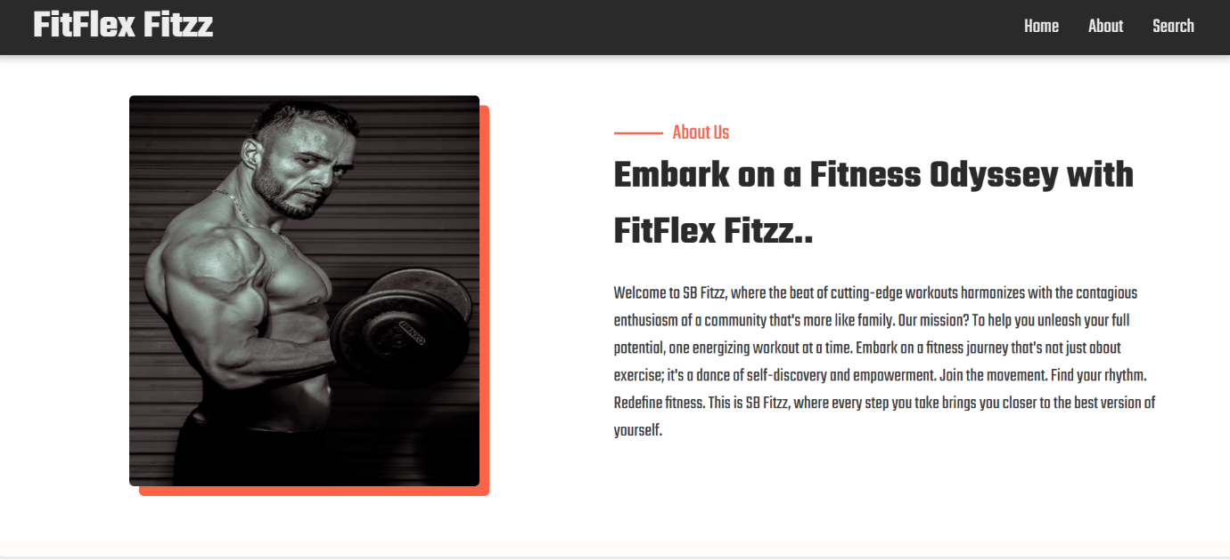

**SEARCH:**

FitFlex Fitzz makes finding your perfect workout effortless. Our prominent search bar empowers you to explore exercises by keyword, targeted muscle group, fitness level, equipment needs, or any other relevant criteria you have in mind. Simply type in your search term and let FitFlex guide you to the ideal workout for your goals.

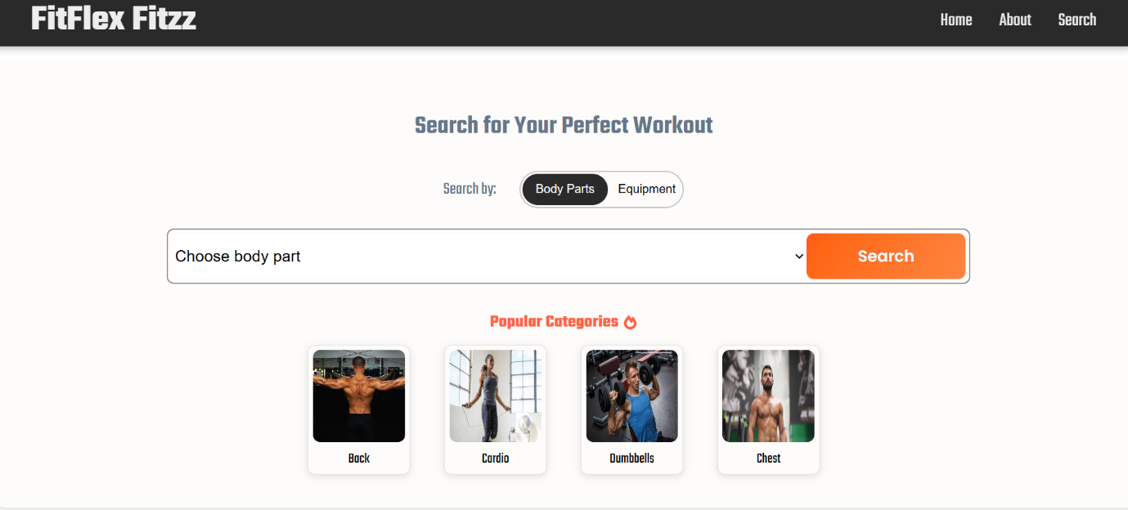

**CATEGORY PAGE:**

FitFlex Fitzz would offer a dedicated section for browsing various workout categories. This could be a grid layout with tiles showcasing different exercise types (e.g., cardio, strength training, yoga) with icons or short descriptions for easy identification.

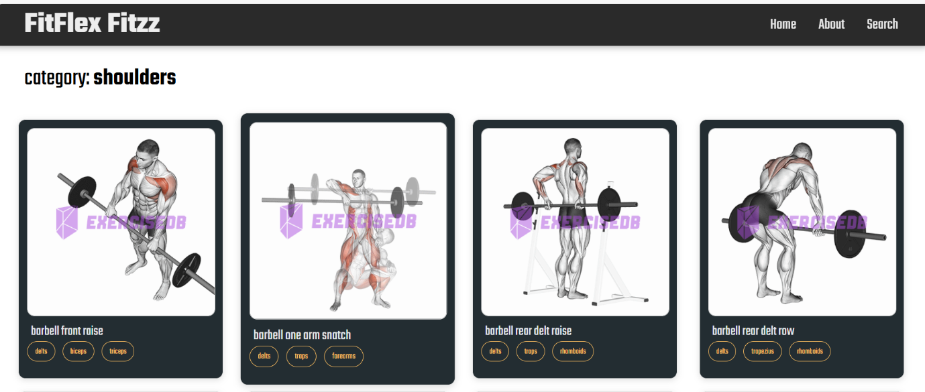

**EXERCISE PAGE:**

This is where the magic happens! Each exercise page on FitFlex provides a comprehensive overview of the chosen workout. Expect clear and concise instructions, accompanied by high-quality visuals like photos or videos demonstrating proper form. Additional details like targeted muscle groups, difficulty level, and equipment requirements (if any) will ensure you have all the information needed for a safe and effective workout.

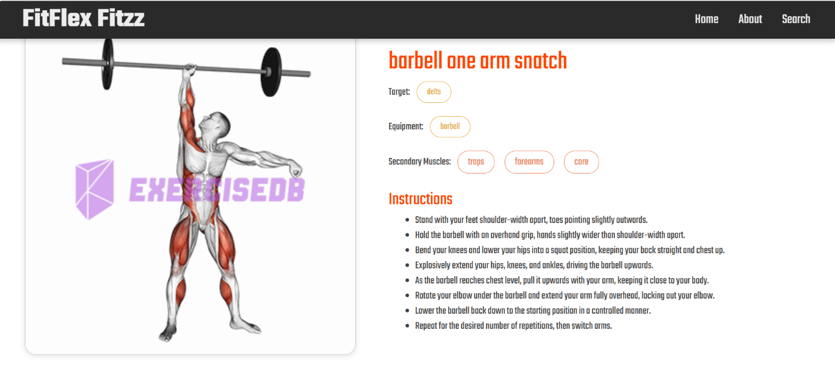

**CONCLUSION:**

FitFlex Fitzz is a user-friendly fitness app designed for all fitness levels, featuring an intuitive interface and easy navigation. The app allows users to find exercises by body part or category, offering a personalized workout experience. Built with React, it ensures smooth performance and dynamic interaction. This project has improved our frontend development and UI/UX design skills, with future plans for real-time fitness tracking and community features. Our goal is to make fitness more engaging, accessible, and results-driven, helping users stay fit and motivated.

**Demo link:**

<https://drive.google.com/file/d/1Qr4jvnPUUk2gzvSI2ljNxoPlt9p7WXX6/view?usp=drive_link>

**HAPPY CODING!......**